**Before multi stage builds:**

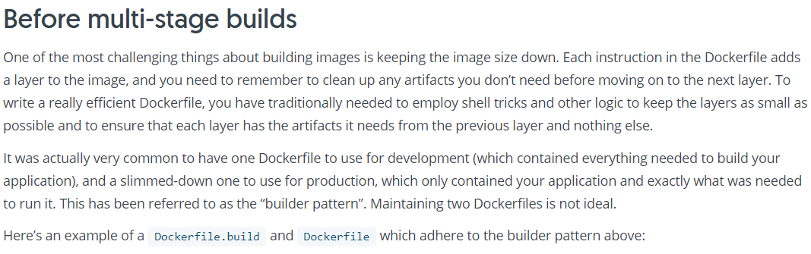

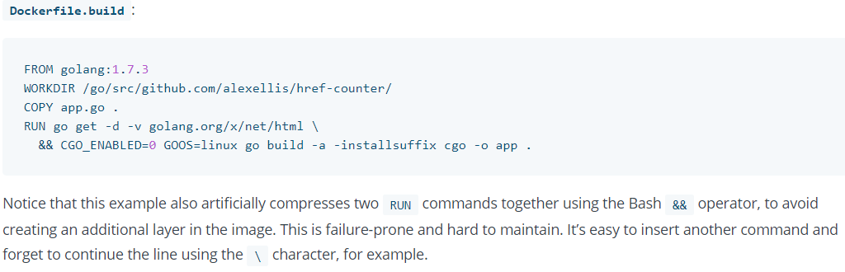

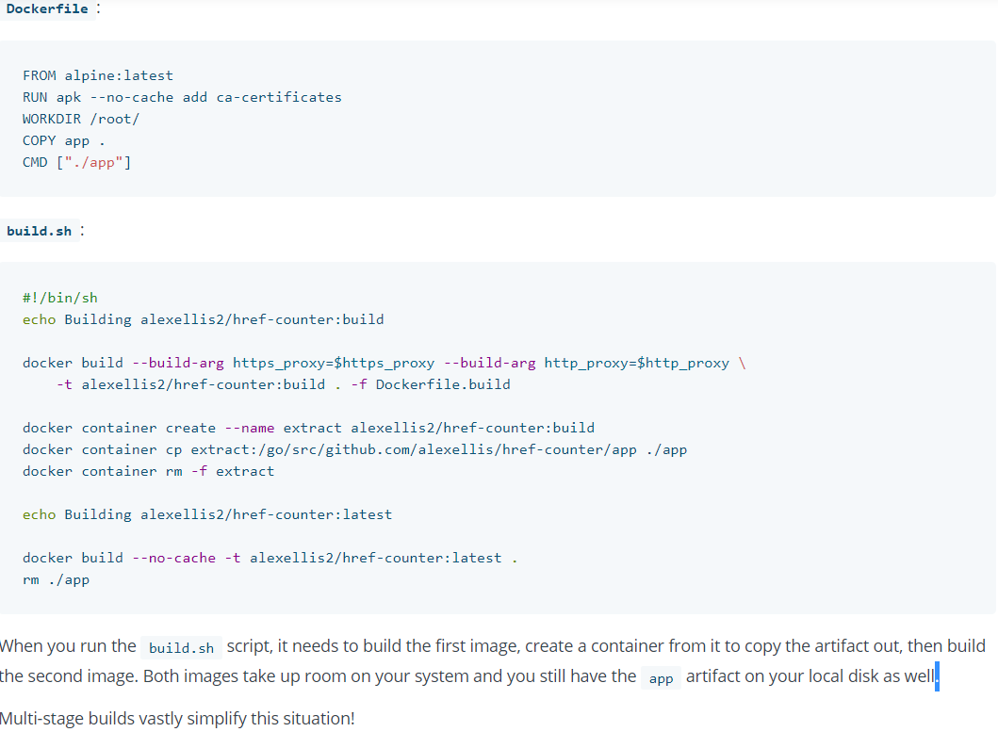

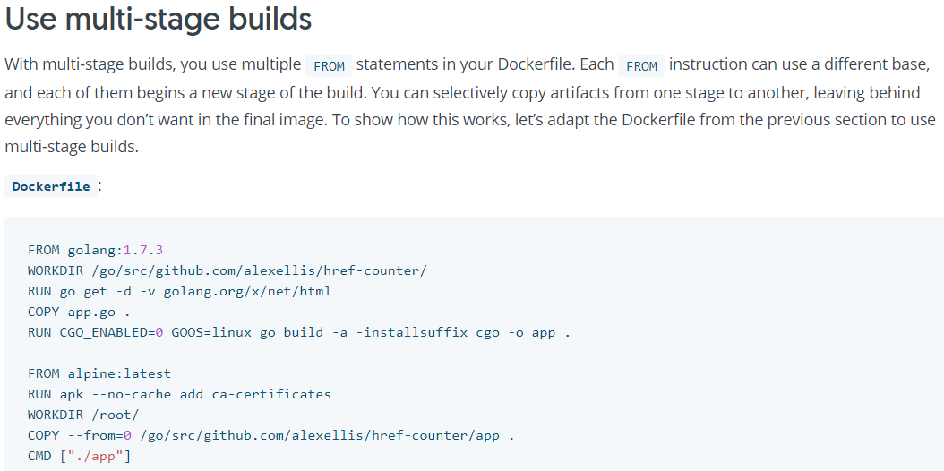

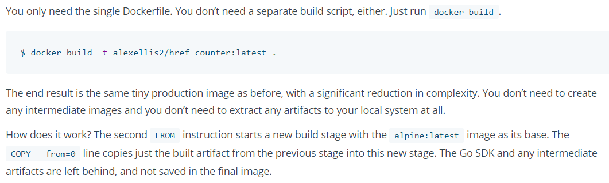

**Note:**

* With this dockerfile, it will create separate images from both the stages and it won’t give any name to the image as because it was not mentioned in dockerfile
* If we give any name with tag while building the docker image, then that name will be assigned to the final stage of dockerfile as below

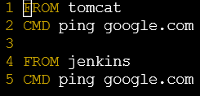



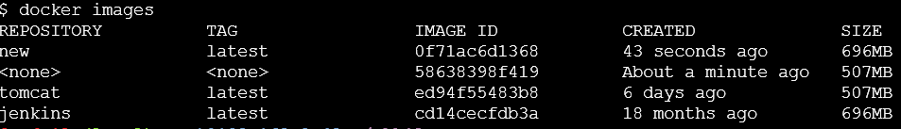

**Naming the Stage:**

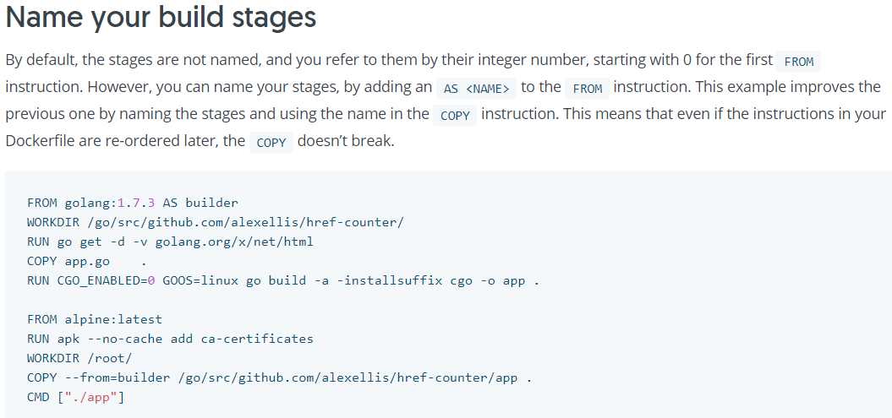

**Note:**

* we can name the stage so that we can copy the artifacts by giving the stage name as above. These are just names for stages not for the images. It won’t take these names for images while building
* even if we name a stage, we can either use the stage name of the stage number in **“COPY –from”** command

**Stop at Specific Stage:**

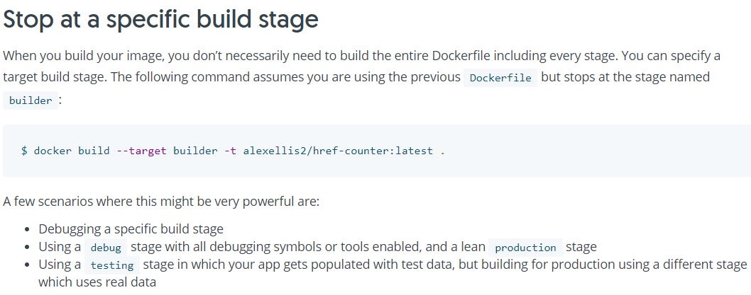

With the above command. We can stop the docker build at specific stage

**COPY artifacts from external images:**

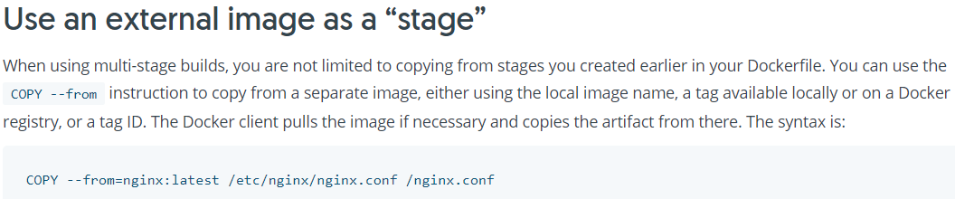

**Previous stage as new stage:**

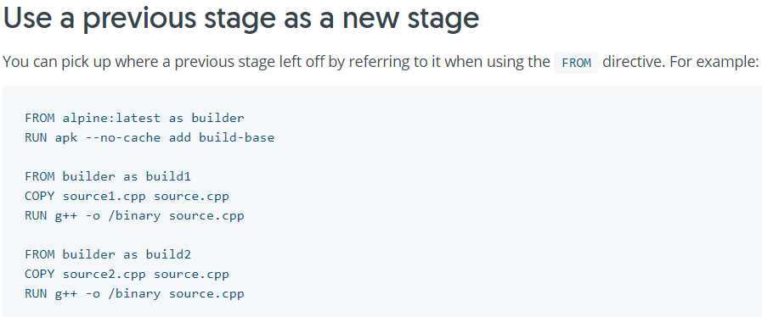

**Advantages:**

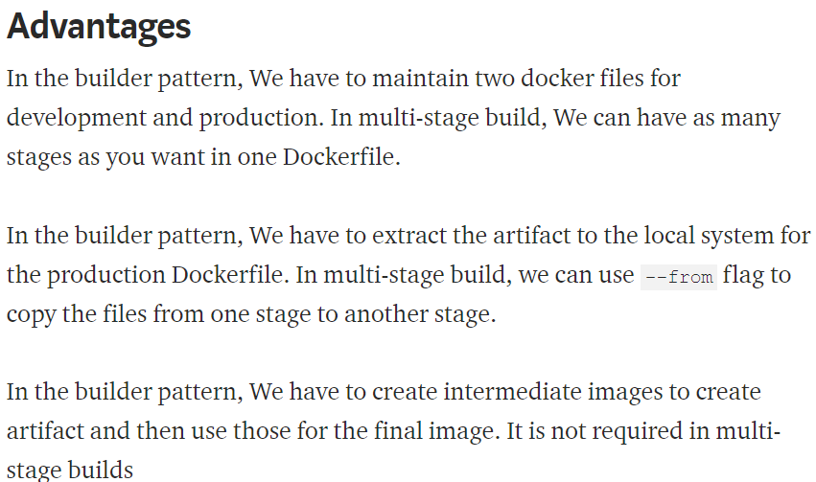

**Example:**

